**­­**

**HEALTH AI SUITE-**

**Intelligent**

**Analytics for Patient Care**

**Project by**

**ASHWITHA K K**

**TOPICS**

1.Introduction

2.Problem Statement

3.Business Use Cases

4.Data Overview

5.Machine Learning

5.1 Risk Stratification (Classification)

5.2 Length of Stay Prediction (Regression)

5.3 Patient Segmentation (Clustering)

5.4 Medical Associations (Association Rules)

6.Deep Learning

6.1 Imaging Diagnostics (CNN)

6.2 Sequence Modelling (RNN / LSTM)

6.3 Sentiment Analysis (deep-learning version)

7.Results (Metrics)

8.Architecture

9.Conclusion

1.Introduction

The Health AI Suite is a comprehensive, end-to-end healthcare intelligence platform that integrates multiple Artificial Intelligence (AI) and Machine Learning (ML) techniques to support early disease detection, health risk prediction, patient monitoring, and clinical decision support. The primary objective of this project is to transform heterogeneous healthcare data—ranging from structured patient records to medical images, time-series vitals, and patient feedback—into actionable clinical insights.

The suite incorporates machine learning–based risk level prediction, where patient demographic details, lifestyle factors, vital signs, and medical history are analysed to classify individuals into Low, Medium, or High health risk categories. In addition, associative learning techniques are used to identify hidden relationships and co-occurrence patterns between diseases, enabling deeper understanding of comorbidities and health trends.

To address medical imaging use cases, the Health AI Suite includes a Convolutional Neural Network (CNN)–based chest X-ray analysis module for automated detection and classification of respiratory and lung-related abnormalities. This module assists in supporting radiological assessment by learning spatial features from X-ray images, enabling faster and more consistent diagnostic insights.

For continuous patient monitoring, the platform integrates **time-series analysis using Recurrent Neural Networks (RNN) and Long Short-Term Memory (LSTM) models**. These models analyse sequential vital signs such as heart rate, blood pressure, oxygen saturation (SpO₂), and respiratory rate to capture temporal patterns and predict patient health deterioration over time.

Furthermore, the Health AI Suite incorporates **sentiment analysis on patient feedback and healthcare reviews** using Natural Language Processing (NLP) techniques. This module evaluates patient sentiment to measure satisfaction levels, identify service quality gaps, and support data-driven improvements in healthcare delivery.

The system is implemented using a modern and scalable architecture, with **Python-based AI models**, **Fast API for backend services**, and an **interactive Stream lit dashboard** for real-time predictions and visual analytics. Model performance is evaluated using standard metrics such as **accuracy, precision, recall, F1-score**, along with **support, confidence, and lift** for associative rule mining.

By unifying predictive analytics, medical imaging, time-series modelling, and sentiment analysis within a single platform, the Health AI Suite demonstrates the practical application of AI in building **intelligent, proactive, and patient-centric healthcare systems**.

**2.Problem Statement**

Modern healthcare systems generate vast and diverse amounts of data, including electronic health records, medical images, continuous vital sign measurements, and patient feedback reviews. However, these data sources are often analysed in isolation, using manual or rule-based approaches that are time-consuming, error-prone, and insufficient for early detection of health risks and disease progression.

Healthcare professionals face significant challenges in:

* Early identification of patient health risks
* Accurate interpretation of medical imaging such as chest X-rays
* Continuous monitoring of patient vitals over time
* Understanding patient satisfaction and feedback at scale
* Discovering hidden disease associations and comorbidities

Existing systems lack a unified, intelligent platform that can seamlessly integrate predictive analytics, deep learning, time-series modelling, and natural language processing to provide holistic and actionable insights. As a result, critical warning signs may go unnoticed, diagnostic processes may be delayed, and opportunities for preventive care and service improvement may be missed.

Therefore, there is a strong need for a scalable, AI-driven healthcare solution that can:

* Predict patient risk levels using clinical and lifestyle data
* Automatically analyse chest X-ray images for disease detection
* Monitor and predict patient health deterioration using time-series vital data
* Analyse patient feedback sentiment to improve healthcare quality
* Provide real-time, explainable insights through interactive dashboards

The Health AI Suite addresses these challenges by integrating multiple AI techniques into a single platform, enabling data-driven clinical decision support, early intervention, and improved patient outcomes.

**3.Business Use Cases**

1. Patient Health Risk Assessment & Preventive Care

Healthcare providers can use the Health AI Suite to predict patient risk levels (Low, Medium, High) based on demographic data, lifestyle factors, and clinical parameters.

Business Value:

* Reduced treatment costs through early intervention
* Improved patient care quality
* Better resource allocation for high-risk cases

2. Length of Stay (LOS) Prediction

Hospitals face challenges in accurately estimating patient Length of Stay, leading to bed shortages, inefficient staff allocation, increased costs, and delayed admissions.

Business Value

* Optimized bed utilization and patient flow
* Improved staff and resource planning
* Reduced operational costs
* Faster admissions and discharge planning

3. Patient Clustering

Healthcare providers struggle to manage diverse patient populations using uniform treatment strategies, leading to inefficient care delivery and resource utilization.

Business Value

* Improved clinical decision-making
* Targeted interventions and preventive care
* Better operational efficiency
* Enhanced patient outcomes

4. Associative Mining

Healthcare organizations often lack visibility into hidden relationships between diseases, symptoms, and patient conditions, making it difficult to identify comorbidities and plan preventive care.

Business Value

* Improved clinical insights and decision support
* Early detection of high-risk disease combinations
* Data-driven care pathways and treatment recommendations

5. CNN-Based Chest X-ray Detection

Manual interpretation of chest X-rays is time-consuming and subject to variability, especially in high-volume hospitals where early detection of lung diseases is critical.

Business Value

* Faster and more consistent X-ray analysis
* Reduced workload for radiologists
* Early detection and timely treatment
* Improved diagnostic support

6. LSTM Time Series Analysis

Continuous patient vital data is difficult to monitor manually, making it challenging to detect early signs of health deterioration in real time.

Business Value

* Early detection of critical conditions
* Reduced ICU readmissions and mortality risk
* Improved patient safety and care quality
* Reduced clinician monitoring burden

7. Feedback Sentiment Analysis

Healthcare organizations receive large volumes of patient feedback and reviews, making it difficult to manually analyse sentiment and identify service quality issues in a timely manner.

Business Value

* Faster insight into patient experience
* Improved healthcare service quality
* Enhanced patient engagement and trust
* Better decision-making for management

**4.Data Overview**

The Health AI Suite utilizes multi-source healthcare data to support predictive modelling, medical imaging analysis, time-series forecasting, and sentiment analysis. The datasets used in this project are a combination of synthetic and publicly available healthcare data, structured to closely resemble real-world clinical scenarios while ensuring data privacy.

1. Patient Clinical & Lifestyle Data

This dataset contains structured patient information used for risk level prediction, clustering, associative mining, and length of stay estimation.

Key Attributes:

* Demographics: Age, Gender
* Lifestyle Factors: Diet, Exercise Frequency, Smoking, Alcohol Consumption, Stress Levels
* Clinical Measurements: BMI, Blood Pressure, SpO₂, Heart Rate, Respiratory Rate
* Medical History: Family History, Chronic Conditions
* Target Variables: Risk Level, Length of Stay

DataType:Structured(Tabular)  
Usage: Supervised & unsupervised ML models

1. Chest X-ray Imaging Data

Chest X-ray images are used for **CNN-based medical image classification and detection** of respiratory and lung-related abnormalities.

**Key Characteristics:**

Grayscale chest X-ray images

Labelled disease categories (e.g., normal vs abnormal)

Pre-processed using resizing, normalization, and augmentation

**Datatype:**Unstructured(ImageData)  
 **Usage:** Deep learning using CNN architectures

1. Time-Series Vital Signs Data

Sequential patient vital sign data is used for **LSTM/RNN-based time-series analysis** to detect trends and predict patient health deterioration.

**Key Attributes:**

* Time-stamped measurements
* Heart Rate
* Blood Pressure (Systolic & Diastolic)
* SpO₂
* Respiratory Rate

**DataType:**Sequential/Time-Series  
**Usage:** LSTM & RNN models

1. Patient Feedback & Review Data

Unstructured text data consisting of patient feedback and reviews is used for **sentiment analysis**.

**Key Attributes:**

* Free-text patient comments
* Service-related feedback
* Satisfaction indicators

**DataType:**Unstructured(TextData)  
**Usage:** NLP-based sentiment classification

1. Data Privacy & Security Considerations

* Use of anonymized and synthetic data
* No personally identifiable information (PII)
* Designed to align with healthcare data protection standards

**5.Machine Learning**

Machine Learning (ML) is a subset of Artificial Intelligence (AI) that enables computer systems to automatically learn patterns from data and make predictions or decisions without being explicitly programmed. Instead of relying on predefined rules, machine learning models improve their performance over time by analysing historical data and identifying underlying relationships within it.

**Why Machine Learning is Important in Healthcare**

Machine Learning (ML) plays a vital role in modern healthcare by enabling systems to analyse complex medical data, identify hidden patterns, and support data-driven decision-making. With the rapid growth of electronic health records, medical imaging, continuous patient monitoring, and patient feedback data, traditional rule-based approaches are no longer sufficient to extract meaningful insights.

Within the Health AI Suite, machine learning techniques are used to build predictive and analytical models such as patient risk level classification, length of stay prediction, patient clustering, and disease association mining. Supervised learning algorithms are applied to predict outcomes like risk categories and hospitalization duration, while unsupervised learning methods are used to identify patient groups with similar characteristics. Additionally, evaluation metrics such as accuracy, precision, recall, F1-score, support, confidence, and lift are used to assess model performance and reliability.

By integrating machine learning into healthcare workflows, the Health AI Suite demonstrates how data-driven intelligence can enhance operational efficiency, enable preventive care, and improve overall patient outcomes.

5.1 Risk Stratification (Classification)

Risk Stratification is a machine learning–based classification approach used to categorize patients into predefined risk groups such as Low, Medium, and High risk based on their clinical, lifestyle, and demographic data. This process helps healthcare providers identify high-risk individuals early and prioritize medical interventions.

In the Health AI Suite, risk stratification is implemented using supervised machine learning classification algorithms trained on patient health records. The model learns patterns from historical data and predicts the risk level of new patients using key features such as age, BMI, blood pressure, lifestyle habits, stress levels, and family medical history.

**Key Points**

* Classifies patients into Low, Medium, and High-risk categories
* Uses supervised ML algorithms (e.g., Random Forest, Logistic Regression)
* Analyses demographic, lifestyle, and clinical features
* Supports early intervention and preventive healthcare
* Improves clinical decision-making and patient prioritization
* Deployed through Fast API and visualized using Streamlit
* Model performance evaluated using accuracy, precision, recall, and F1-score

**Data Preprocessing & EDA Analysis:**

Data preprocessing is a critical step to ensure data quality, consistency, and reliability before applying machine learning models. In the Health AI Suite, multiple preprocessing techniques are applied to transform raw healthcare data into a model-ready format.

**Data Cleaning**

* Identified and handled missing values using appropriate strategies (mean/median imputation or removal).
* Removed duplicate records to avoid biased learning.
* Corrected inconsistent or invalid values in clinical measurements.

**Handling Categorical Variables**

* Converted categorical features such as diet, smoking status, alcohol consumption, and family history into numerical form using encoding techniques.
* Ensured consistent encoding between training and deployment environments**.**

**Feature Scaling & Normalization**

* Applied feature scaling to numerical attributes such as age, BMI, blood pressure, and vitals.
* Normalization helped improve model convergence and ensured equal feature contribution

**Outlier Detection & Treatment**

* Identified outliers in clinical parameters like BMI and blood pressure using statistical techniques.
* Reduced the impact of extreme values to improve model robustness.

**Feature Selection**

* Selected clinically relevant features contributing most to risk prediction and LOS estimation.
* Removed redundant or low-importance features to reduce model complexity.

**Data Splitting**

* Split the dataset into **training and testing sets** to evaluate model generalization.
* Maintained class balance where applicable.

**Exploratory Data Analysis (EDA) Steps**

Exploratory Data Analysis (EDA) was performed to understand data distribution,

identify patterns, and uncover relationships between variables before model development.

**Understanding Data Structure**

* Examined dataset dimensions, feature types, and data distributions.
* Verified target variable balance for classification tasks.

**Descriptive Statistics**

* Analysed mean, median, standard deviation, and ranges of numerical features.
* Helped understand patient health trends and variability.

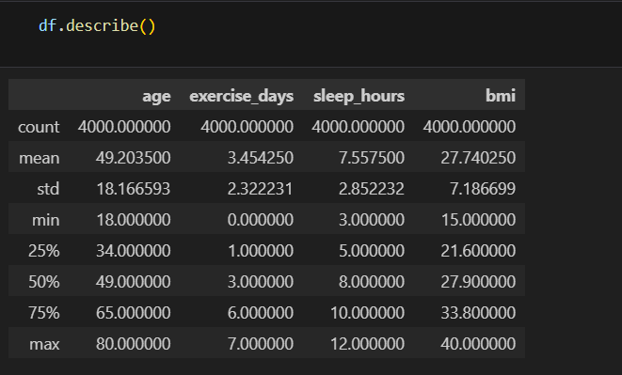

**Univariate Analysis**

* Visualized distributions of individual features such as **age, BMI, blood pressure, and vitals**.
* Identified skewness and potential outliers.

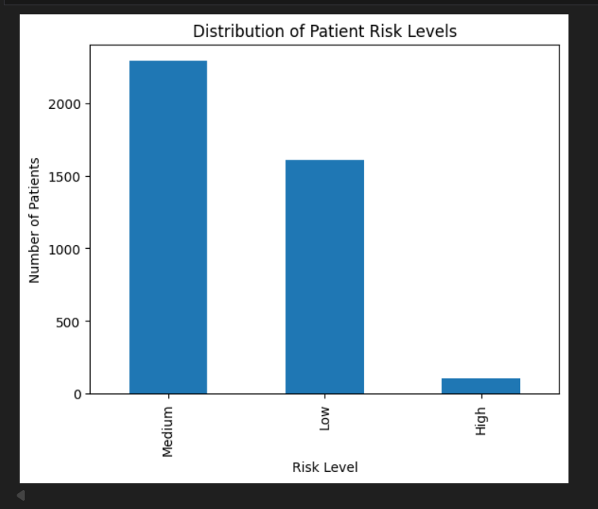

Low risk dominates (realistic population health data)

High-risk patients are rare → class imbalance

**Bivariate & Multivariate Analysis**

* Studied relationships between features and target variables (risk level, LOS).
* Used correlation analysis to identify influential predictors.

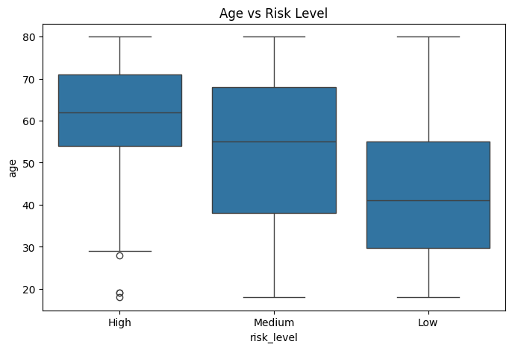

Median age increases from Low → Medium → High

Age is a strong risk indicator

Confirms model learning is medically meaningful

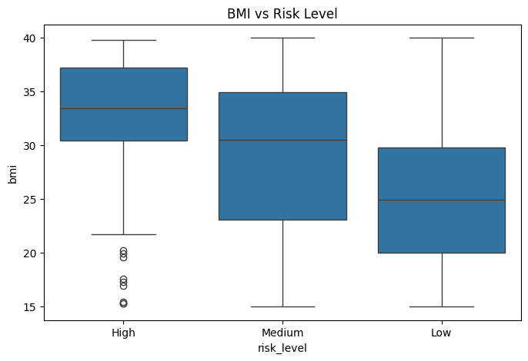

Higher BMI → higher risk

Obesity clusters in Medium & High risk

BMI is a key modifiable risk factor

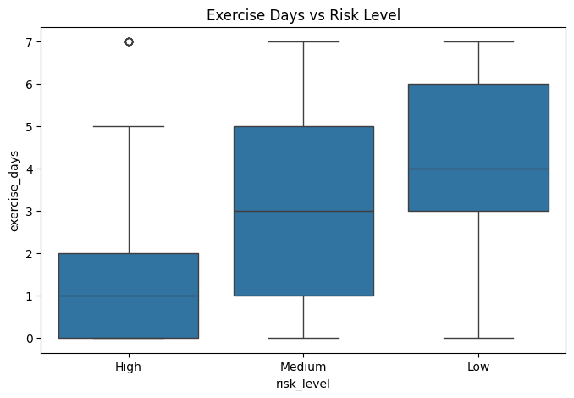

As exercise days decrease → risk increases

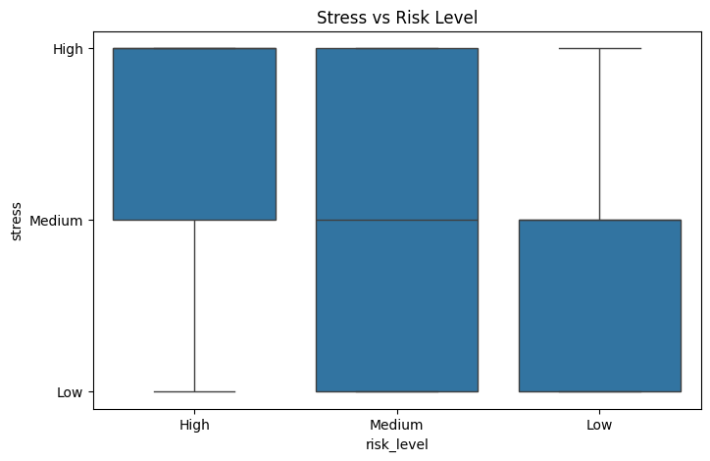

High-risk patients predominantly show medium to high stress levels

Medium-risk patients display a wide stress range, indicating mixed mental health states

Low-risk patients mostly experience low to medium stress

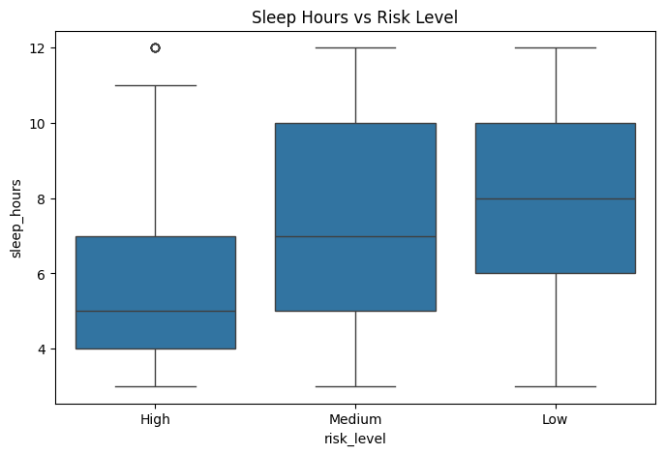

High-risk patients sleep the least (median ≈ 5 hours), indicating sleep deprivation

Medium-risk patients show moderate sleep (≈ 6–7 hours) with high variability

Low-risk patients get the most consistent and adequate sleep (≈ 7–8 hours)

**MODEL DEVELOPMENT**

Model development focuses on building a reliable machine learning–based classification

System to predict patient health risk levels as Low, Medium, or High using processed

clinical and lifestyle data.

**Model Selection**

Evaluated multiple supervised classification algorithms.

Selected Random Forest Classifier due to:

* High performance on structured healthcare data
* Ability to handle non-linear relationships
* Robustness to noise and outliers
* Built-in feature importance estimation

**Model Evaluation**

Evaluated model performance on unseen test data using:

* Accuracy
* Precision
* Recall
* F1-score

Ensured reliable classification across all risk categories.

**Model Insights**

* The model accurately distinguishes patients at risk level.
* F1-score: 98.32% indicates strong classification performance.

**Outcome**

* Successfully developed a scalable and accurate risk stratification model.
* Enabled real-time patient risk prediction for clinical decision support.

**Streamlit Dashboard Implementation**

The Streamlit dashboard serves as the **user-facing interface** of the Health AI Suite,

enabling real-time interaction with machine learning models through a simple and intuitive

web application.

**Objective**

* Provide an interactive platform for users to input patient data.
* Display real-time predictions and insights generated by AI models.
* Enable easy visualization of healthcare analytics without technical expertise.

**Dashboard Design**

* Built using **Streamlit**, a Python-based web framework.
* Designed with a clean, responsive, and user-friendly layout.
* Organized into sections for data input, prediction output, and visualization.

**User Input Module**

* Allows users to enter patient information such as:
  + Age, BMI, lifestyle habits
  + Vital signs and medical history
* Input validation ensures accurate and complete data entry.

**Model Integration**

* Loads the trained **risk level prediction model** using pickle/joblib.
* Ensures feature alignment between input data and trained model.
* Sends processed input data to the model for inference.

**Prediction & Output Display**

* Displays predicted **Risk Level (Low / Medium / High)** in real time.
* Provides confidence or probability-based insights where applicable.
* Uses visual indicators (text, colors, alerts) to improve interpretability.

**Screenshot of Streamlit:**

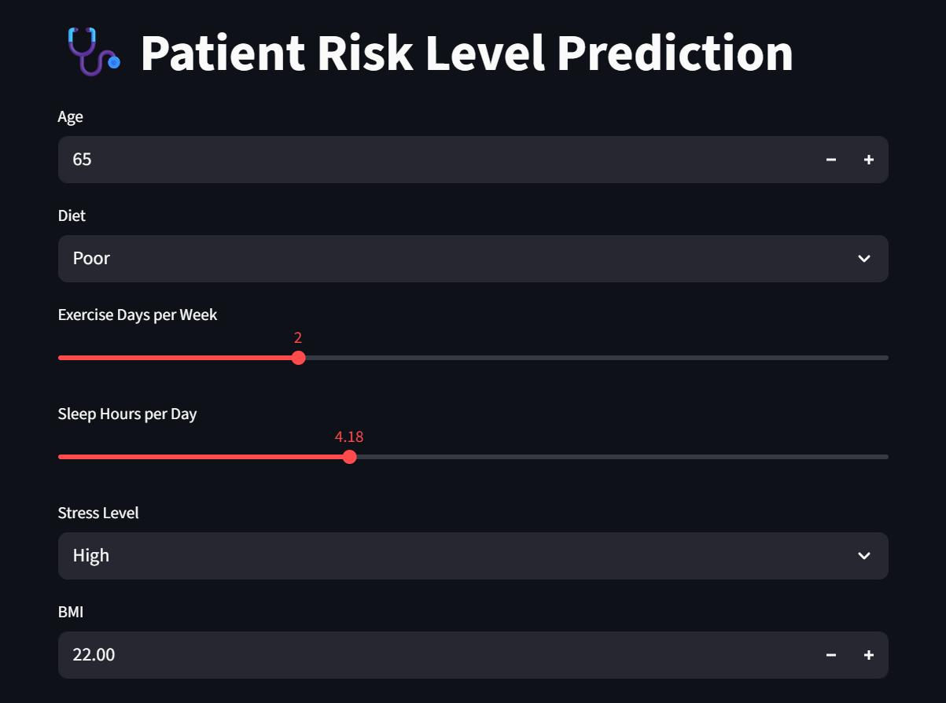 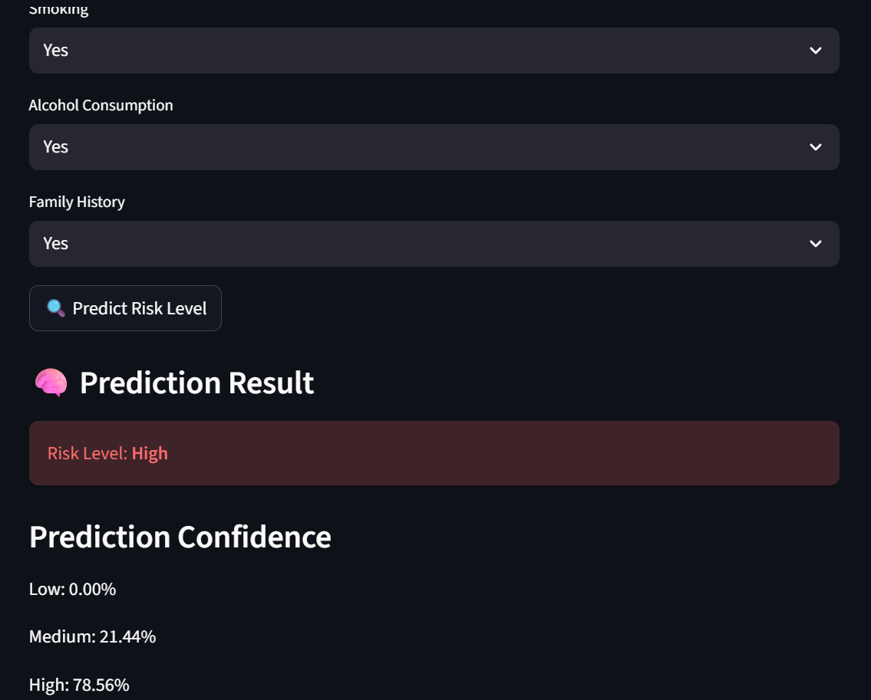

**Outcome**

* Successfully implemented an interactive dashboard for real-time healthcare prediction.
* Improved accessibility and usability of AI-driven healthcare insights.

5.2 **Length of Stay Prediction (Regression)**

Length of Stay (LOS) prediction aims to estimate the expected number of days a patient will

**remain hospitalized** based on clinical, demographic, and admission-related data. Accurate LOS

reduction supports efficient hospital operations and improved patient care planning.

**Key Points**

* Predicts the expected number of days a patient will stay in the hospital
* Formulated as a supervised regression problem
* Uses patient demographics, clinical vitals, diagnosis, and admission details
* Helps in bed availability planning and discharge management
* Machine learning models capture non-linear relationships in healthcare data
* Performance evaluated using MAE, RMSE, and R² score
* Identifies key factors contributing to prolonged hospital stays
* Deployed through Fast API and visualized using Streamlit dashboard
* Supports data-driven hospital operations and cost optimization

**Data Preprocessing & EDA Analysis**

**Data Preprocessing**

Data preprocessing ensures that raw healthcare data is clean, consistent, and suitable for machine

learning model development.

**Key Steps:**

* Removed duplicate and inconsistent patient records
* Handled missing values using appropriate statistical methods
* Encoded categorical variables into numerical format
* Scaled and normalized numerical features for uniformity
* Detected and treated outliers in clinical parameters
* Selected relevant features to reduce noise and complexity
* Split data into training and testing datasets

**Exploratory Data Analysis (EDA)**

Exploratory Data Analysis (EDA) was performed to understand data patterns, distributions, and

and relationships before model training.

**Understanding Data Structure**

* Examined dataset dimensions, feature types, and data distributions.
* Verified target variable balance for classification tasks.

**Descriptive Statistics**

* Analysed mean, median, standard deviation, and ranges of numerical features.
* Helped understand patient health trends and variability.

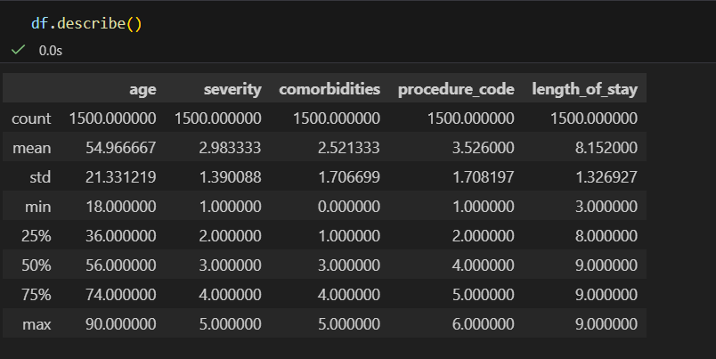

**Univariate Analysis**

* Visualized distributions of individual feature
* Identified skewness and potential outliers.

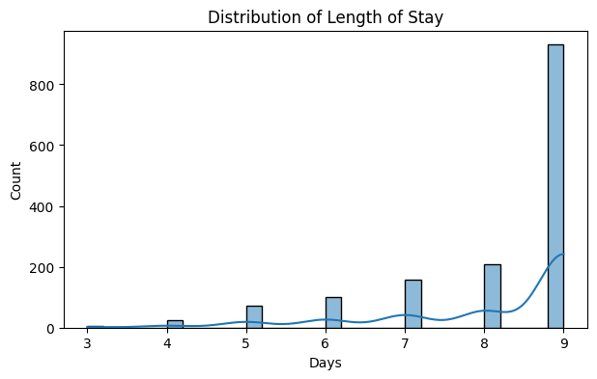

**Bivariate & Multivariate Analysis**

* Studied relationships between features and target variables (Length of stay).
* Used correlation analysis to identify influential predictors.

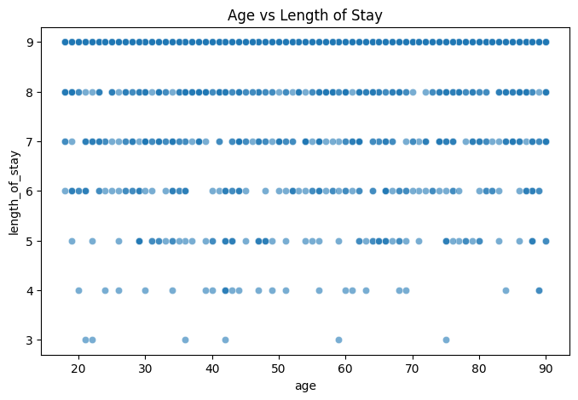

LOS increases with age

Elderly patients require longer monitoring

Age is a strong predictor

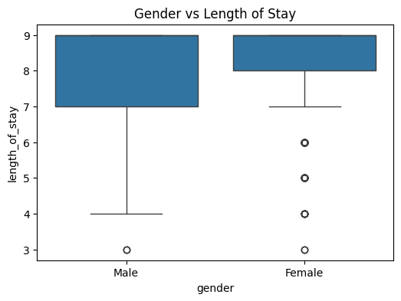

Slight LOS variation across gender

Gender alone is not a dominant predictor

Works best when combined with severity/comorbidities

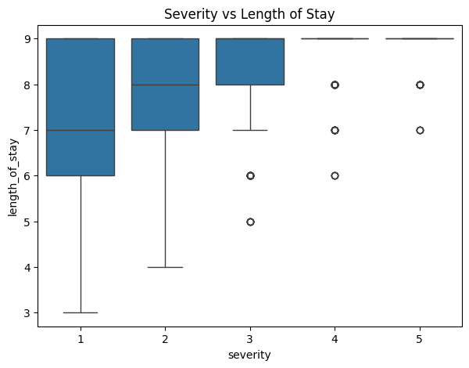

Clear monotonic trend:

Low → Medium → High severity → Higher LOS

Severity is one of the strongest predictors

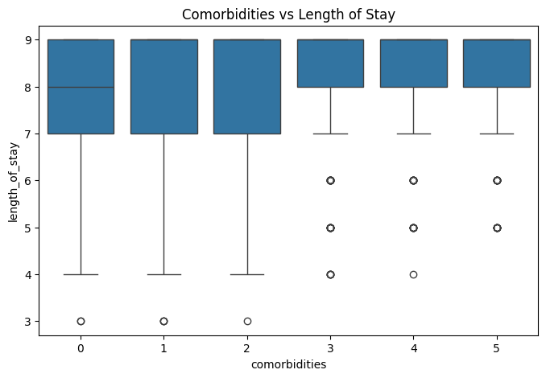

LOS increases with number of comorbidities

Multi-morbid patients require extended care

Strong clinical relevance

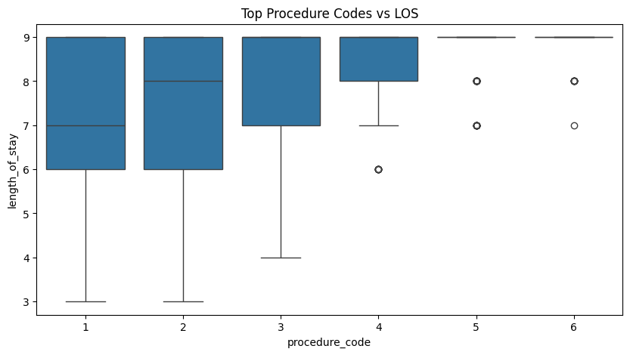

Complex procedures lead to longer hospitalization

Procedure complexity directly affects LOS

**MODEL DEVELOPMENT**

The model development phase focuses on building a **machine learning–based regression model**

to accurately predict the hospital length of stay (LOS) for patients using clinical and admission

-related data.

**Model Selection**

Evaluated multiple regression algorithms.

Chosen models include:

* Linear Regression (baseline)
* Random Forest Regressor
* Gradient Boosting Regressor

Tree-based models were preferred for capturing non-linear patterns.

**Model Evaluation**

* Assessed model performance using:
  + Mean Absolute Error (MAE)
  + Root Mean Squared Error (RMSE)
  + R² Score
* Compared predicted LOS with actual LOS values.

**Model Insights**

* The model accurately predicts LOS for patients.
* R^2 82% indicates strong regression performance.

**Outcome**

* Successfully developed an AI-driven LOS prediction model.
* Enabled proactive hospital resource planning and discharge optimization.

**Streamlit Dashboard Implementation**

The Streamlit dashboard provides an interactive interface for predicting the expected hospital

length of stay using the trained regression model.

**Objective**

* Enable users to input patient and admission details.
* Provide real-time LOS predictions to support hospital planning.

**Dashboard Design**

* Developed using **Streamlit** for rapid web application deployment.
* Clean and intuitive layout for easy navigation.
* Separate sections for input, prediction, and result display

**User Input Module**

* Accepts patient and admission parameters such as:
  + Age, gender
  + Vital signs
  + Diagnosis severity
  + ICU admission status
* Input validation ensures accurate data entry.

**Model Integration**

* Loads the trained **LOS regression model** using joblib/pickle.
* Ensures consistency between input features and model expectations.
* Processes inputs into model-ready format.

**Prediction & Output Display**

* Displays predicted **Length of Stay (in days)**.
* Uses clear numeric output and visual indicators.
* Helps clinicians and administrators understand expected hospitalization duration.

**Screenshot of Streamlit:**

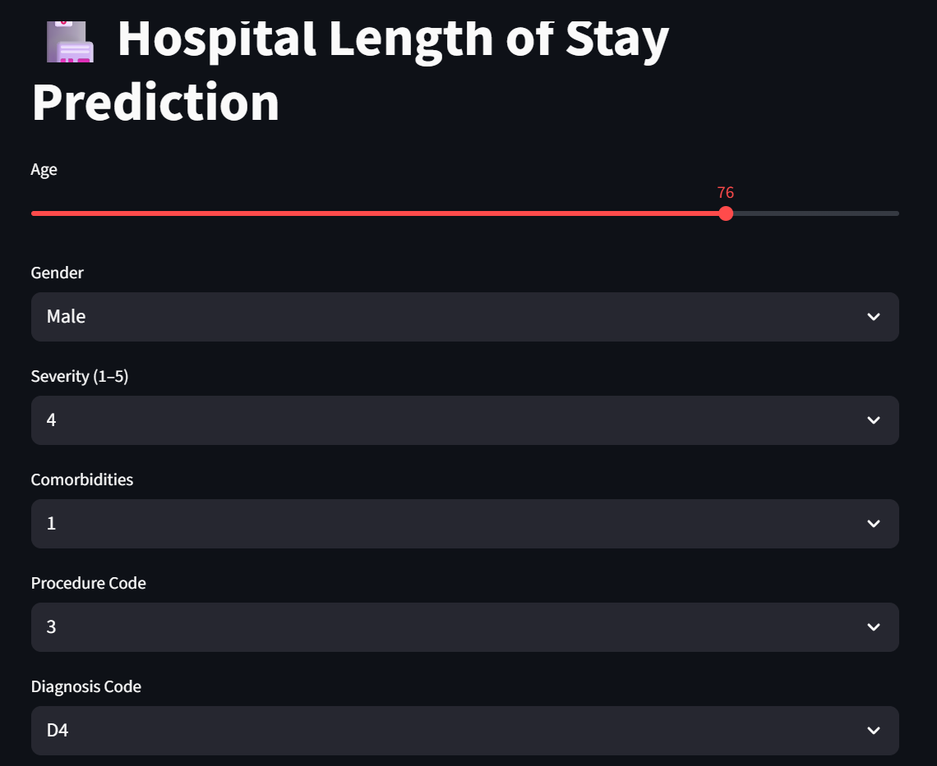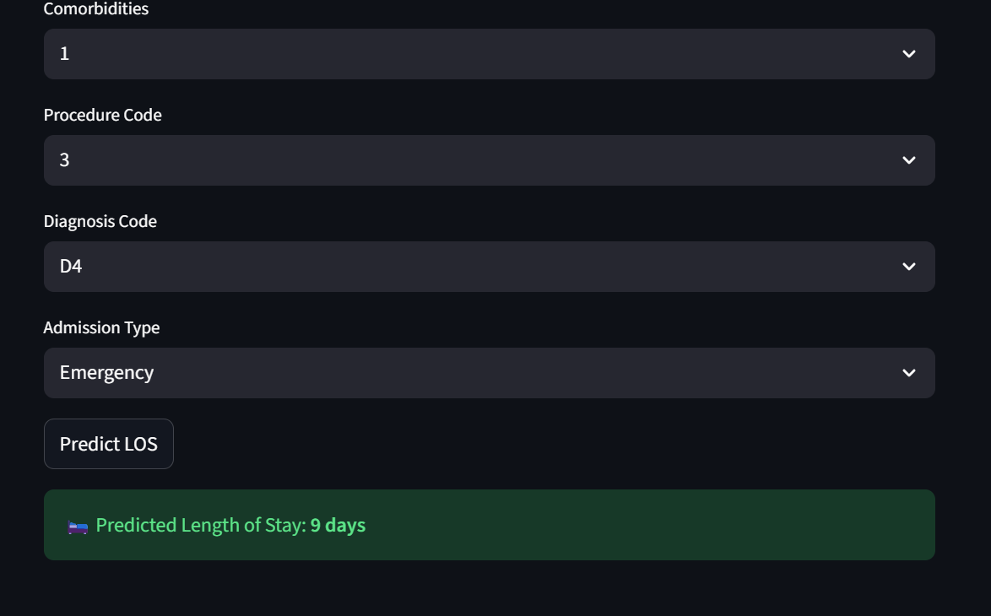

**Outcome**

* Successfully implemented an interactive LOS prediction dashboard.
* Improved decision support for bed management and discharge planning.

**5.3 Patient Segmentation (Clustering)**

Patient Segmentation is an unsupervised machine learning approach used to group patients with

similar clinical characteristics, lifestyle patterns, and health risk profiles. Unlike classification,

clustering does not use predefined labels; instead, it discovers hidden structures within patient

data.

In the Health AI Suite, patient segmentation helps in understanding population-level health

Patterns and supports personalized care, targeted interventions, and efficient resource

allocation.

**Key Points**

* Implemented using **unsupervised learning algorithms** such as K-Means and Hierarchical Clustering
* Groups patients based on similarities in:
  + Demographics (age, gender)
  + Lifestyle factors (diet, exercise, smoking, alcohol)
  + Clinical measurements (BMI, blood pressure, vitals)
* Helps identify **high-risk patient clusters** without predefined labels
* Supports **population health management and preventive care planning**
* Enables personalized treatment strategies for different patient groups
* Reduces healthcare cost through targeted interventions
* Visualized using cluster plots and summary statistics

**Data Preprocessing**

Data preprocessing is essential to improve data quality and ensure reliable machine learning model

performance.

**Key Steps:**

* Removed duplicate and inconsistent patient records
* Handled missing values using appropriate statistical techniques
* Encoded categorical variables into numerical form
* Scaled and normalized numerical features for uniform contribution
* Identified and treated outliers in clinical measurements
* Selected relevant features to reduce noise and model complexity
* Split data into training and testing datasets

**Exploratory Data Analysis (EDA)**

Exploratory Data Analysis was conducted to understand data characteristics and uncover meaningful

Patterns.

**Understanding Data Structure**

* Examined dataset dimensions, feature types, and data distributions.
* Verified target variable balance for classification tasks.

**Descriptive Statistics**

* Analysed mean, median, standard deviation, and ranges of numerical features.
* Helped understand patient health trends and variability.

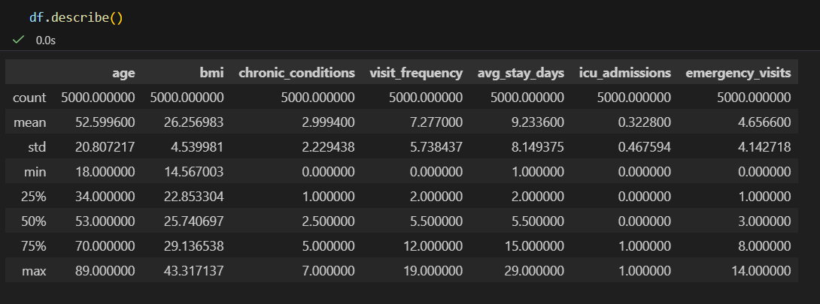

**Univariate Analysis**

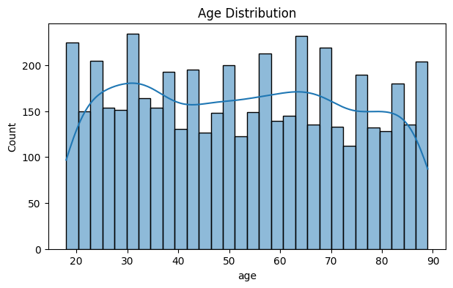

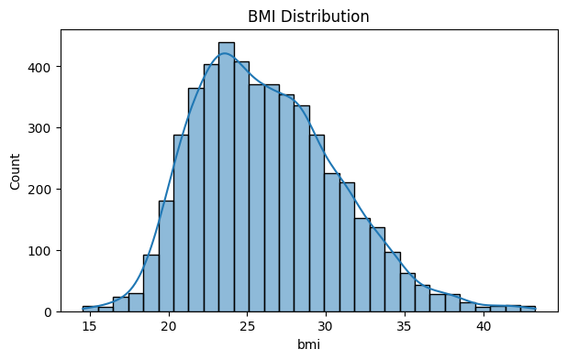

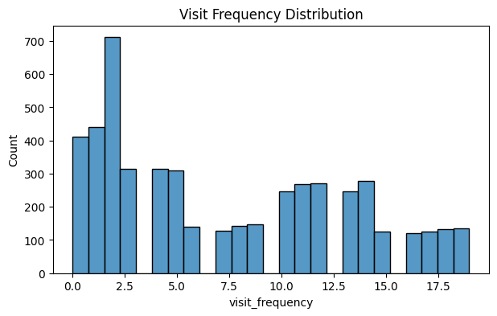

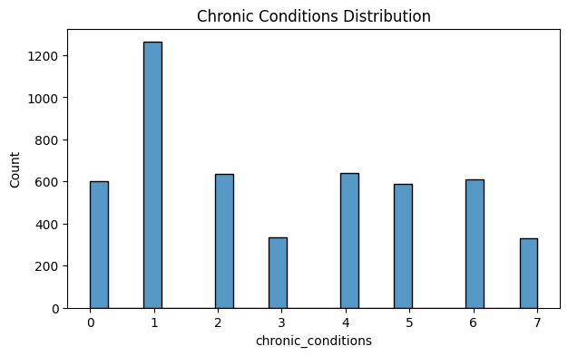

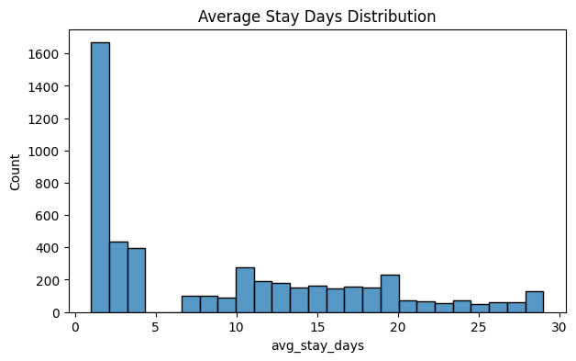

**Bivariate & Multivariate Analysis**

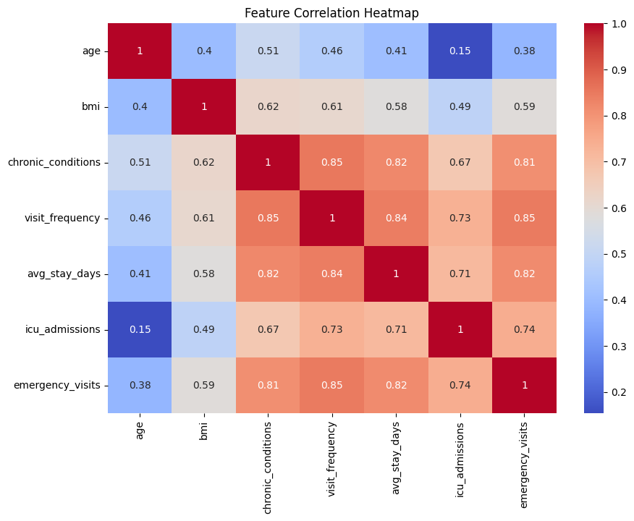

Moderate correlation between:

Age ↔ chronic conditions

Visit frequency ↔ avg stay

Low multicollinearity → good for clustering

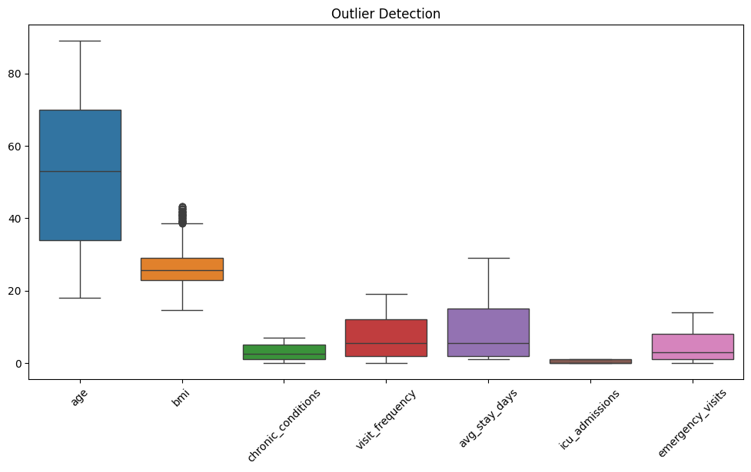

Outliers exist but are clinically meaningful

Should NOT be removed for clustering

Represent high-risk/high-cost patients

**Model Development**

The model development phase focuses on building an unsupervised machine learning model to

Group patients into meaningful segments based on similarities in their demographic,

lifestyle, and clinical attributes.

**Algorithm Selection**

* Evaluated clustering algorithms including:
  + K-Means Clustering
  + Hierarchical Clustering
* Chose **K-Means** due to its simplicity, scalability, and effectiveness on structured healthcare data.

**Optimal Cluster Determination**

* Determined the optimal number of clusters using:
  + Elbow Method
  + Silhouette Score
* Ensured clusters were well-separated and meaningful.

**Cluster Interpretation**

* Analysed cluster centroids to understand patient characteristics.
* Identified high-risk and low-risk patient segments.
* Mapped clusters to clinical and lifestyle patterns.

**Visualization**

* Visualized clusters using:
  + Scatter plots
  + Dimensionality reduction techniques (PCA)
* Enhanced interpretability of patient groups

**Model Evaluation Metrics**

Final Cluster Mapping:

0: 'Young Healthy', 2: 'Middle-Aged Preventive', 3: 'Elderly Chronic', 1: 'High-Acuity’

* Silhouette scores:

K=2, Silhouette Score=0.518 K=3, Silhouette Score=0.466

K=4, Silhouette Score=0.369 K=5, Silhouette Score=0.358

K=6, Silhouette Score=0.353 K=7, Silhouette Score=0.351

**Outcome**

* Successfully segmented patients into distinct groups.
* Enabled targeted healthcare strategies and personalized interventions.

**Streamlit Dashboard Implementation**

The Streamlit dashboard provides an interactive interface to visualize and interpret **patient**

**segmentation results** generated using unsupervised machine learning techniques.

**Objective**

* Enable users to explore patient clusters interactively.
* Visualize patient groupings based on clinical and lifestyle similarities.
* Support data-driven insights for personalized healthcare strategies.

**Dashboard Design**

* Developed using **Streamlit** for rapid web application deployment.
* Clean and intuitive layout for ease of navigation.
* Structured sections for data input, clustering results, and visualizations.

**Data Input & Selection**

* Allows users to select features for clustering (age, BMI, vitals, lifestyle factors).
* Supports uploading or selecting pre-processed datasets.
* Ensures consistent feature scaling before clustering.

**Model Integration**

* Loads the trained **clustering model** (e.g., K-Means).
* Applies the model to assign patients to clusters.
* Ensures real-time cluster assignment for new patient data.

**User Interaction**

* Allows dynamic selection of number of clusters.
* Updates visualizations and summaries in real time.
* Enhances exploratory analysis and decision-making.

**Cluster Interpretation**

* Shows summary statistics for each cluster.
* Describes key characteristics such as risk profile and lifestyle patterns.
* Helps identify high-risk or priority patient groups.

**Screenshots**

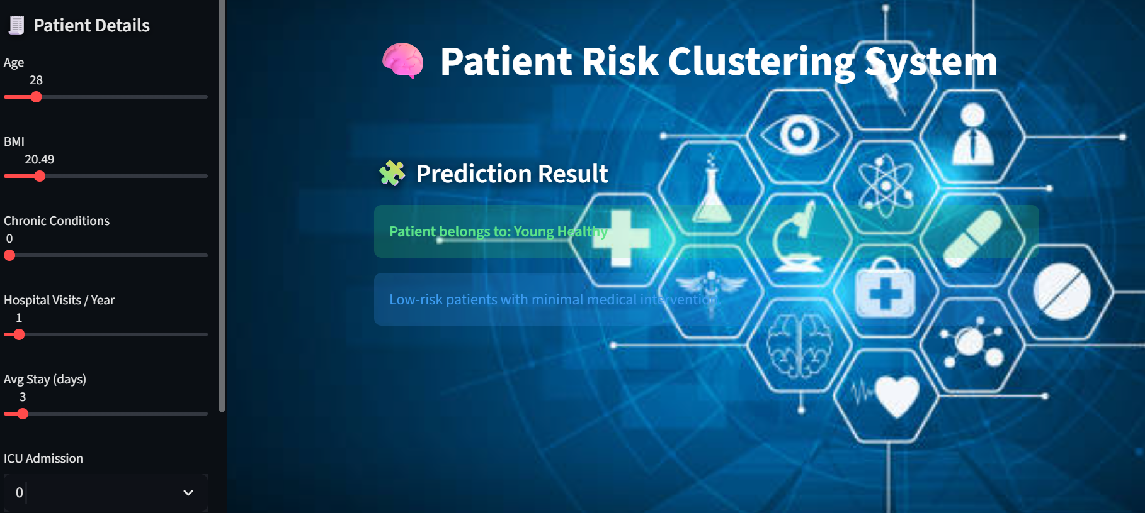

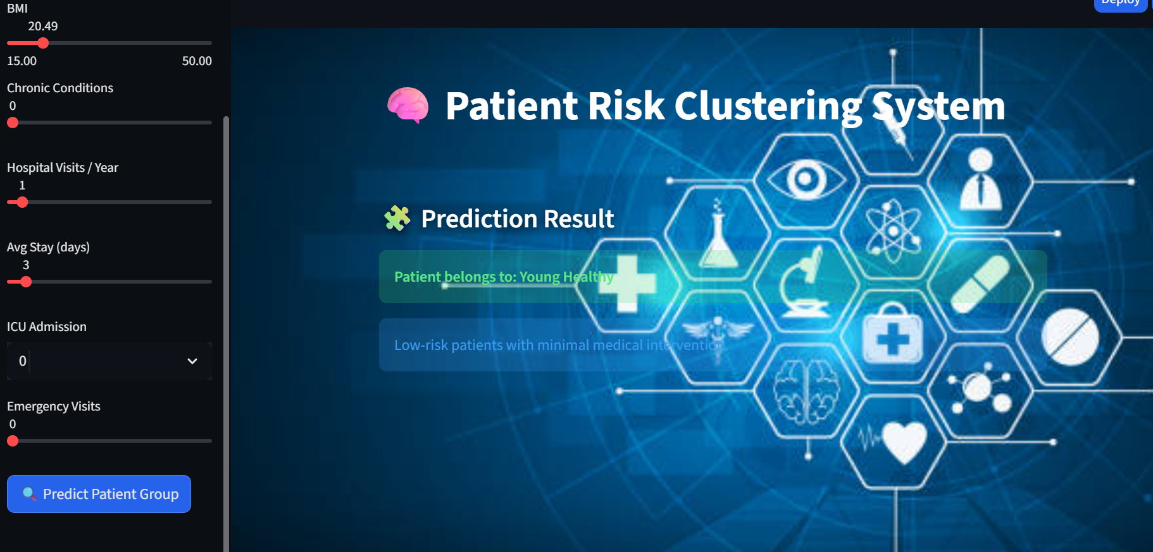

**Outcome**

* Successfully implemented an interactive clustering dashboard.
* Enabled intuitive exploration of patient segments for clinical and operational use.

**5.4 Medical Associations (Association Rules)**

Medical Association Rule Mining is a data mining technique used to discover hidden relationships

And co-occurrence patterns among diseases, symptoms, and medical conditions. It helps identify

how frequently certain conditions occur together and the strength of their relationships**.**

Key Points

* Implemented using association rule mining techniques such as Apriori
* Discovers frequent disease combinations and medical condition relationships
* Uses key metrics:
  + Support – frequency of disease occurrence
  + Confidence – likelihood of co-occurring diseases
  + Lift – strength of association beyond random chance
* Helps identify common comorbidities (e.g., diabetes–hypertension)
* Supports early screening and preventive healthcare planning
* Enhances clinical understanding of disease relationships
* Provides data-driven insights for population health analysis

**Data Preprocessing & EDA Analysis**

**Data Preprocessing**

Data preprocessing ensures the healthcare dataset is clean, consistent, and suitable for machine learning

and deep learning models.

Key Steps:

* Removed duplicate and inconsistent patient records
* Handled missing values using statistical imputation techniques
* Encoded categorical variables into numerical representations
* Scaled and normalized numerical features to maintain uniformity
* Detected and treated outliers in clinical measurements
* Selected relevant features to reduce noise and model complexity
* Split data into training and testing datasets

**Exploratory Data Analysis (EDA)**

Exploratory Data Analysis was performed to understand data patterns, distributions, and relationships

among variables.

**Understanding Data Structure**

* Examined dataset dimensions, feature types, and data distributions.
* Verified target variable balance for classification tasks.

**Descriptive Statistics**

* Analysed mean, median, standard deviation, and ranges of numerical features.
* Helped understand patient health trends and variability.

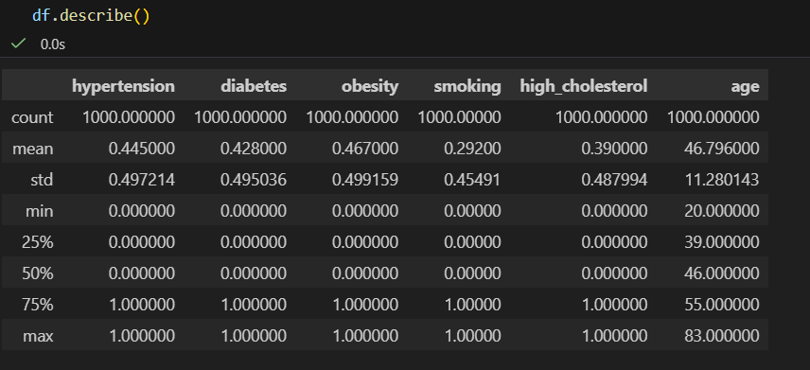

**Univariate Analysis**

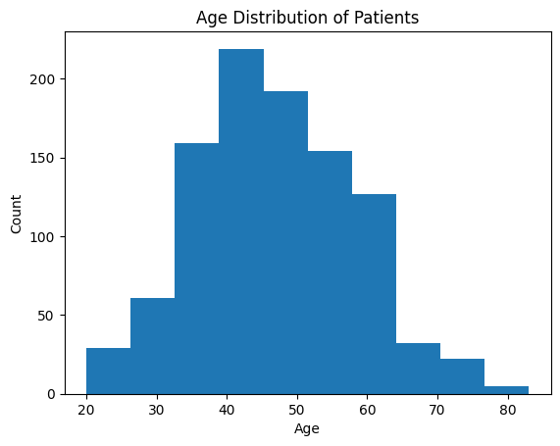

Most patients fall in middle-aged and elderly groups, which is clinically relevant for chronic diseases.

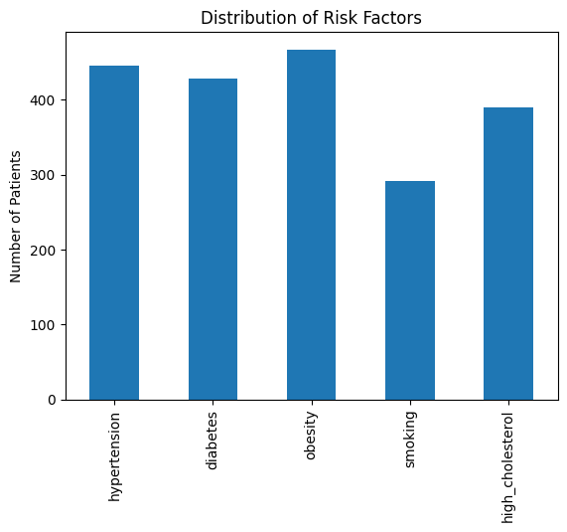

Obesity & hypertension are most frequent

Justifies strong associations with heart disease

**Bivariate & Multivariate Analysis**

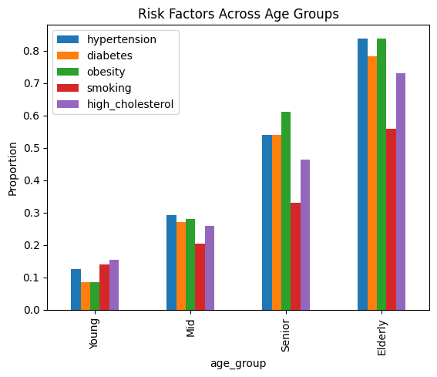

Senior/Elderly → higher hypertension & diabetes

Justifies age-based associations

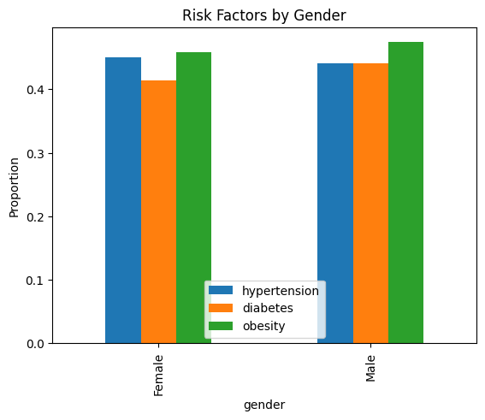

Male patients show higher prevalence of cardiovascular risk factors, supporting gender-based risk modelling.

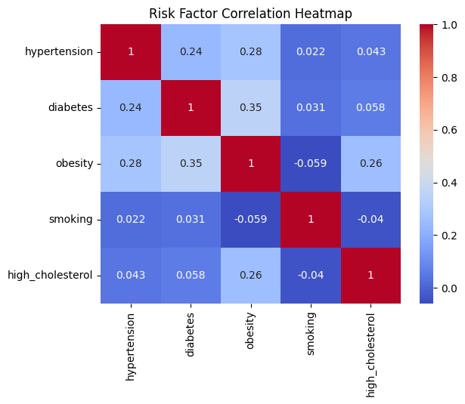

Obesity ↔ Diabetes ↔ Hypertension strongly correlated

Confirms association rule learning is appropriate

**Model development**

The associative learning module focuses on discovering hidden relationships and co- occurrence patterns

among medical conditions using association rule mining techniques.

**Algorithm Selection**

* Implemented **Apriori algorithm** for frequent itemset generation.
* Chosen due to:
  + Interpretability of results
  + Suitability for healthcare association analysis
  + Wide acceptance in medical data mining

**Frequent Itemset Generation**

* Applied minimum **support threshold** to identify frequent disease patterns.
* Generated itemset representing commonly co-occurring medical conditions.

**Association Rule Generation**

* Derived association rules from frequent item sets.
* Used key evaluation metrics:
  + **Support** – frequency of disease combination
  + **Confidence** – likelihood of disease co-occurrence
  + **Lift** – strength of association beyond random occurrence

**Rule Filtering & Optimization**

* Filtered rules based on confidence and lift thresholds.
* Retained only clinically meaningful and strong associations.
* Reduced redundant or weak rules.

**Association Rule Mining Results:**

* **🔹 Support**
* Shows how frequently a disease combination occurs
* Example: 25% patients have both diabetes and hypertension
* **🔹 Confidence**
* Measure’s reliability of the association
* Example: 58% of diabetic patients also have hypertension
* **🔹 Lift**
* Indicates strength of association
* Lift > 1 means strong correlation beyond chance

**Outcome**

* Successfully identified meaningful medical associations.
* Provided actionable insights for preventive care and population health analysis.

**STREAMLIT DASHBOARD IMPLEMENTATION**

The Streamlit dashboard provides an interactive interface to explore, analyse, and interpret **medical**

Association rules derived from patient data.

**Objective**

* Enable users to visualize disease associations easily.
* Present frequent disease combinations and comorbidities interactively.
* Support clinical and business decision-making using association insights.

**Dashboard Design**

* Developed using Streamlit for rapid web application deployment.
* Simple and intuitive layout for healthcare users.
* Organized sections for rule generation, filtering, and visualization.

**Data Input & Configuration**

* Allows users to upload or select patient diagnosis datasets.
* Enables dynamic adjustment of:
  + Minimum **support**
  + Minimum **confidence**
  + **Lift** threshold
* Ensures real-time rule regeneration based on user inputs.

**Model Integration**

* Integrates the **Apriori-based association rule model**.
* Processes transactional medical data efficiently.
* Generates frequent itemsets and association rules dynamically.

**Interactive Filtering**

* Allows filtering of rules based on metric thresholds.
* Enables sorting to identify the strongest associations.
* Improves clarity and reduces information overload.\

**Screenshot of Streamlit**

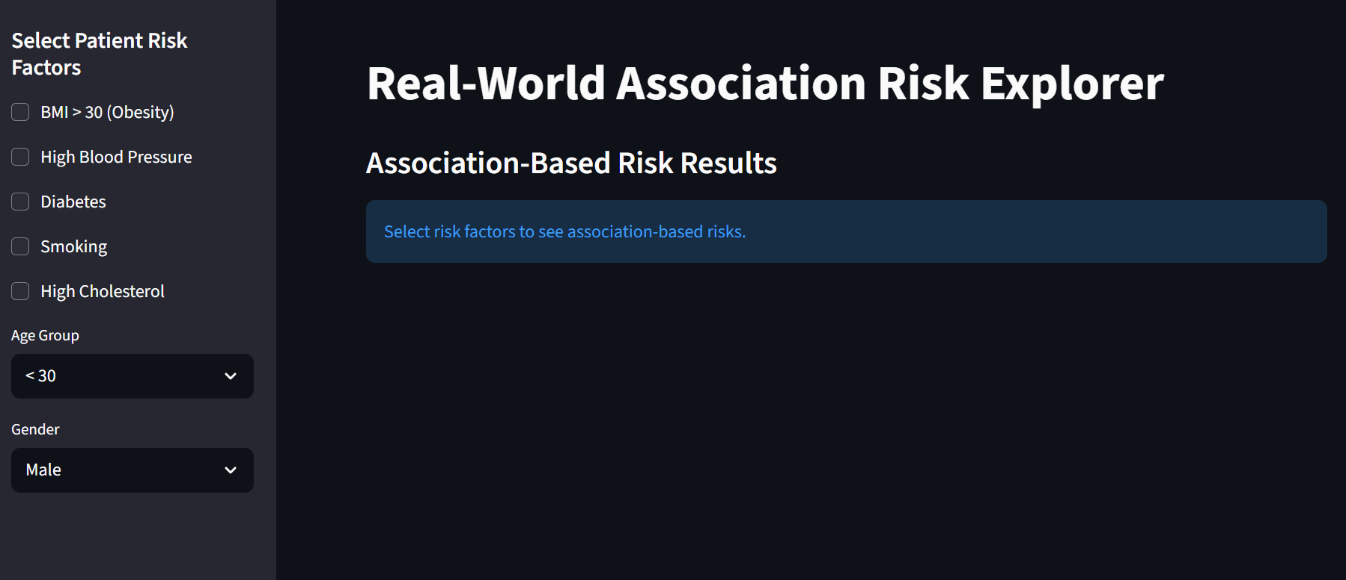

**Outcome**

* Successfully implemented an interactive association rule dashboard.
* Enabled intuitive exploration of medical relationships for decision support**.**

**6.Deep Learning**

Deep Learning is a subset of machine learning that uses multi-layered neural networks to automatically

Learn complex patterns from large and high-dimensional data such as medical images, time-series

vitals, and unstructured text.

In the **Health AI Suite**, deep learning techniques are applied to solve advanced healthcare problems that

require high accuracy and automated feature extraction.

**Advantages in Healthcare**

* High predictive accuracy
* Automated feature learning
* Scalable for real-world healthcare systems
* Supports real-time and predictive analytics

**6.1 Imaging Diagnostics (CNN)-** **Chest X-Ray Detection**

Convolutional Neural Networks (CNNs) are deep learning models specifically designed for image analysis.

In the Health AI Suite, a CNN-based model is implemented to automatically detect abnormalities

from **chest X-ray images**, supporting faster and more accurate clinical diagnosis.

**Dataset Description**

* Chest X-ray images collected and organized into labelled classes
* Images represent different pulmonary conditions and normal cases
* Dataset split into training, validation, and testing sets
* Images resized and normalized for CNN compatibility

**Data Preprocessing**

* Image resizing to a fixed input dimension
* Pixel normalization for faster convergence
* Data augmentation techniques applied:
  + Rotation
  + Zoom
  + Horizontal flipping
* Improves model generalization and reduces overfitting

**Model Architecture**

* Implemented using a **CNN with ResNet-based architecture**
* Key components:
  + Convolutional layers for feature extraction
  + Batch normalization for training stability
  + ReLU activation for non-linearity
  + Pooling layers for dimensionality reduction
  + Fully connected layers for classification
* Transfer learning used to leverage pre-trained weights

**Model Training**

* Loss function: Categorical/Binary Cross-Entropy
* Optimizer: Adam
* Trained for multiple epochs with validation monitoring
* Early stopping used to prevent overfitting

**Model Evaluation**

* Performance evaluated using:
  + Accuracy
  + Precision
  + Recall
  + F1-score
* Validation and test results analysed to ensure robustness
* Confusion matrix used to understand classification behavior

**Results & Insights**

* CNN successfully learned discriminative features from chest X-ray images
* Demonstrated high accuracy in identifying abnormal cases
* Reduced false negatives, supporting early disease detection

**Outcome**

* Successfully implemented a CNN-based chest X-ray detection system.
* Enhanced diagnostic intelligence within the Health AI Suite.

**STREAMLIT DASHBOARD IMPLEMENTATION**

The Streamlit dashboard enables real-time chest X-ray image analysis using a trained CNN (ResNet-based)

model, providing an intuitive interface for clinical users.

**Objective**

* Provide an easy-to-use interface for chest X-ray image upload and analysis
* Enable real-time disease detection using a CNN model
* Support faster and consistent diagnostic assistance

**Dashboard Design**

* Developed using **Streamlit** for rapid deployment
* Clean and user-friendly layout suitable for healthcare environments
* Modular design separating input, prediction, and results

**Image Upload & Preprocessing**

* Allows users to upload chest X-ray images (PNG/JPG formats)
* Automatically resizes images to the required input dimensions
* Normalizes pixel values to match model training conditions

**Model Integration**

* Loads the trained **ResNet-based CNN model**
* Uses transfer learning for efficient inference
* Ensures consistency between training and deployment pipelines

**Prediction & Output**

* Performs real-time inference on uploaded images
* Displays predicted class (Normal / Abnormal)
* Shows confidence scores for better interpretability

**Visualization**

* Displays the uploaded chest X-ray image
* Highlights prediction results clearly
* Enhances transparency and trust in model outputs

**Screenshots of streamlit**

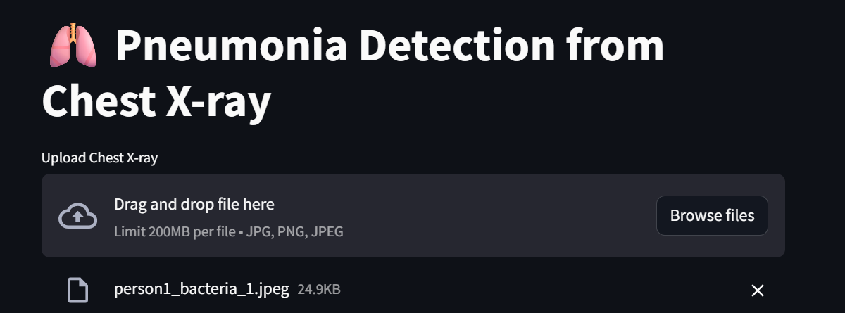

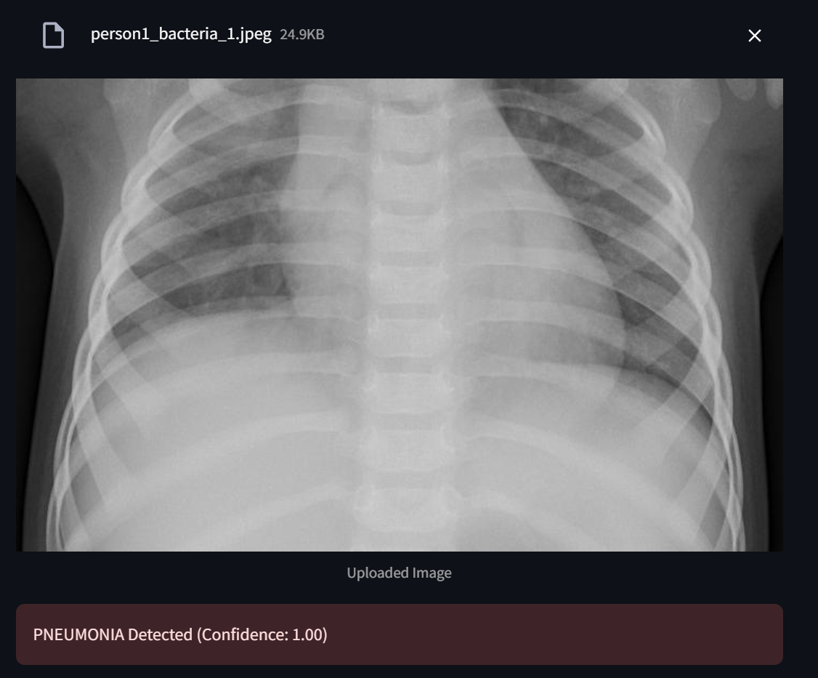

**Outcome**

* Successfully deployed a CNN-based chest X-ray detection system via Streamlit
* Enabled real-time, interpretable, and user-friendly medical image analysis

**6.2 Sequence Modelling (RNN / LSTM)**

Sequence modelling using Recurrent Neural Networks (RNN) and Long Short-Term **Memory (LSTM)**

networks is applied to analyse **time-series healthcare data**. This approach capture temporal

dependencies in patient vitals to predict health trends and potential deterioration.

**Dataset Description**

* Time-series patient data including vital signs collected at regular intervals
* Features include heart rate, blood pressure, oxygen saturation, and respiratory rate
* Each patient record represented as a sequence of observations

**Data Preprocessing**

* Sorted patient data chronologically
* Handled missing time steps and irregular sampling
* Normalized vital sign values for stable training
* Converted data into supervised learning sequences
* Created sliding windows for temporal learning

**EDA**

Exploratory Data Analysis (EDA) was performed to understand the structure, quality, and patterns

In the healthcare dataset before model development. EDA helps in identifying trends, anomalies, and

relationships that guide feature selection and model design.

**Dataset Understanding**

* Examined dataset dimensions and feature types
* Identified numerical and categorical variables

**Descriptive Statistics**

* Computed mean, median, standard deviation, and range
* Analysed central tendencies of vital signs and clinical metrics
* Identified skewness in health indicators

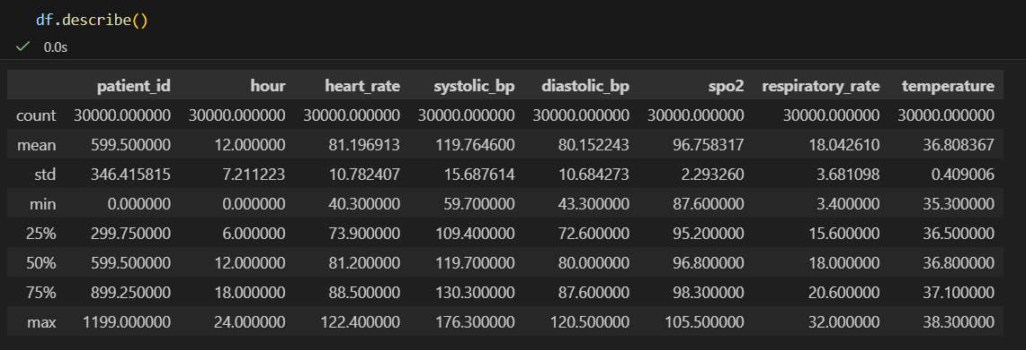

**Univariate Analysis:**

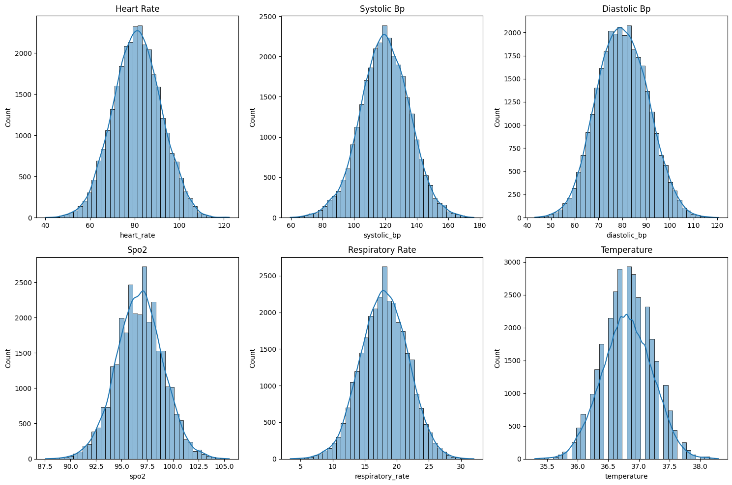

HR: right-skew → tachycardia cases

SpO₂: left tail → hypoxia

RR: wider spread → respiratory distress

**Bivariate & multivariate Analysis**

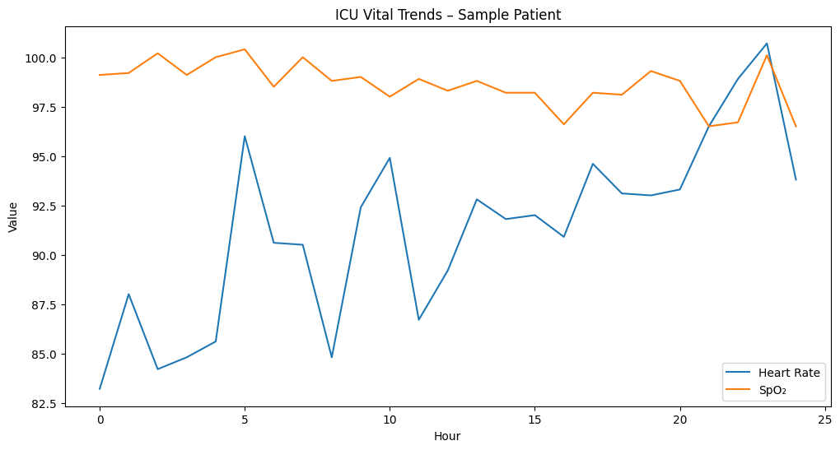

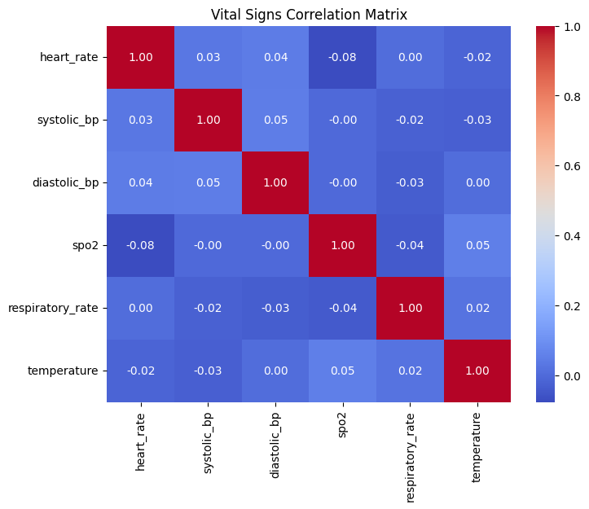

HR ↑ ↔ RR ↑

SpO₂ ↓ ↔ HR ↑

BP moderately independent

**Model Architecture**

* Implemented **LSTM-based neural network**
* Key components:
  + Input layer for sequential data
  + One or more LSTM layers to capture long-term dependencies
  + Dropout layers to reduce overfitting
  + Dense output layer for prediction/classification

**Model Training**

* Loss function: Mean Squared Error / Categorical Cross-Entropy
* Optimizer: Adam
* Trained over multiple epochs with validation monitoring
* Early stopping used to prevent overfitting

**Results & Insights**

* LSTM successfully captured temporal trends in patient vitals
* Improved prediction accuracy over traditional models
* Enabled early identification of abnormal health patterns

**Streamlit Dashboard Implementation**

Streamlit is used to develop an interactive web-based dashboard that enables real-time interaction with

machine learning and deep learning models in the Health AI Suite. The dashboard bridges the gap

between complex AI models and end users such as clinicians and administrators.

**Objective**

* Provide a user-friendly interface for healthcare analytics
* Enable real-time predictions and visual insights
* Improve accessibility of AI-driven decision support

**Dashboard Design**

* Developed using **Streamlit framework**
* Clean, intuitive, and responsive user interface
* Modular layout for different healthcare use cases

**User Input & Interaction**

* Accepts patient details, clinical metrics, and medical images
* Supports sliders, dropdowns, file uploads, and text inputs
* Validates user input to prevent errors

**Model Integration**

* Loads pre-trained ML and DL models
* Ensures consistency between training and inference pipelines
* Supports real-time prediction and analysis

**Screenshots of Streamlit**

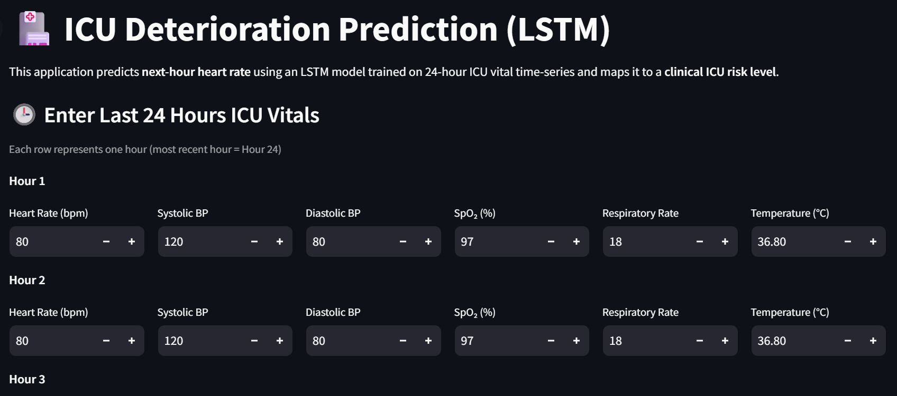

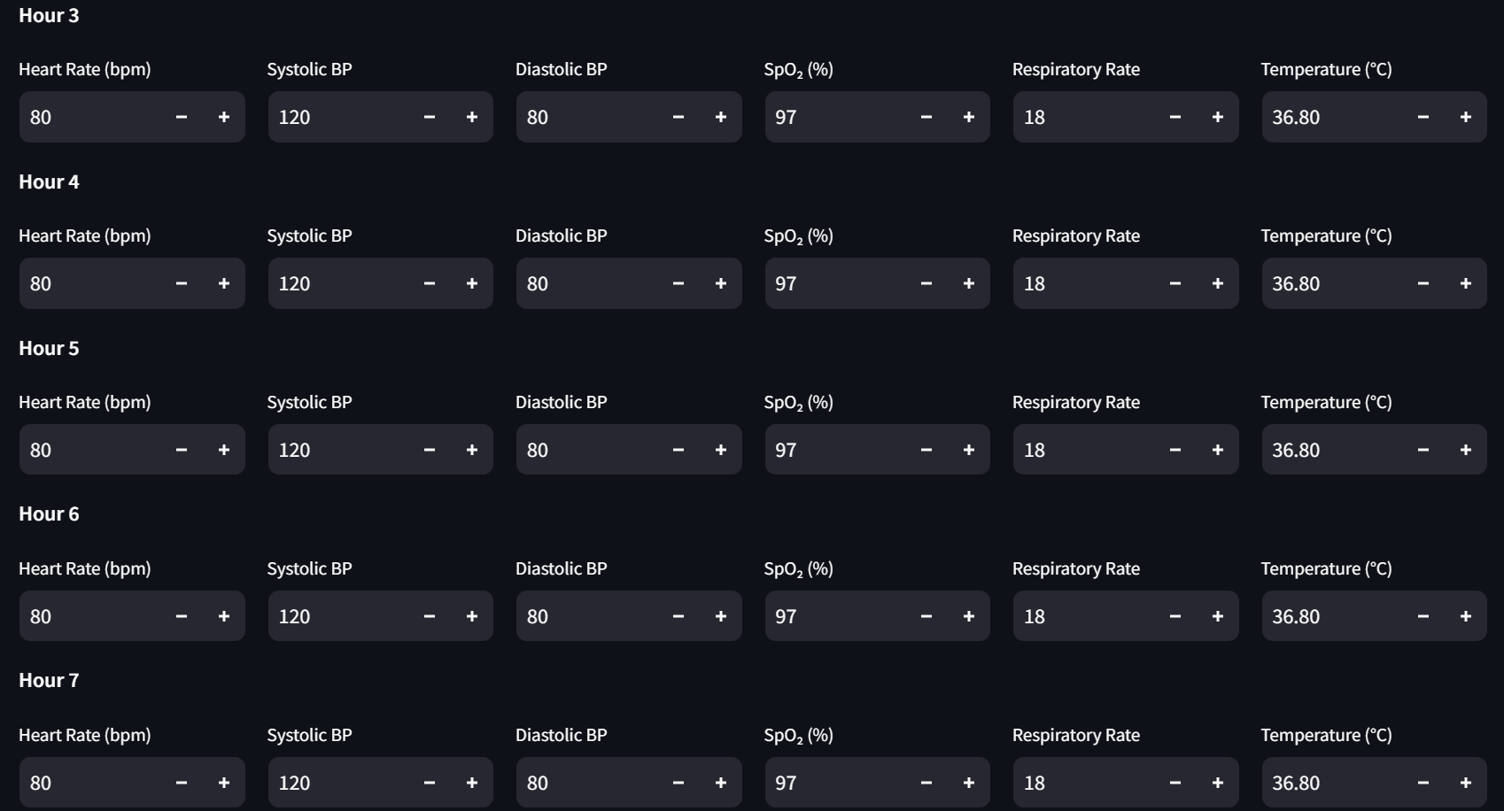

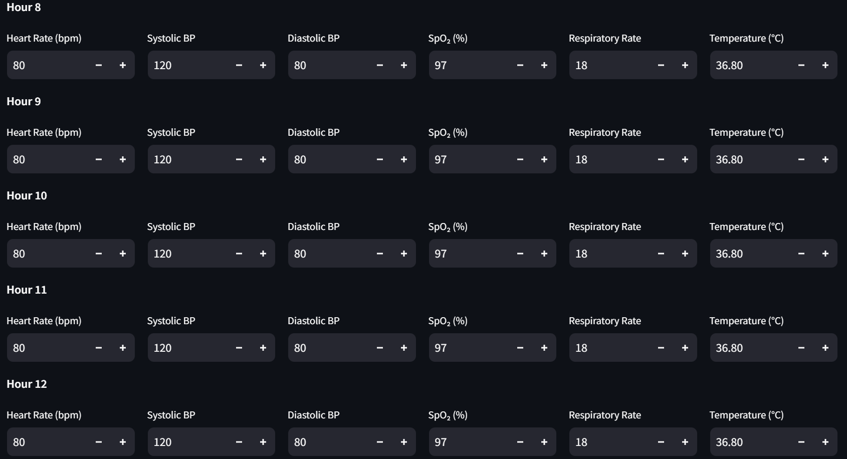

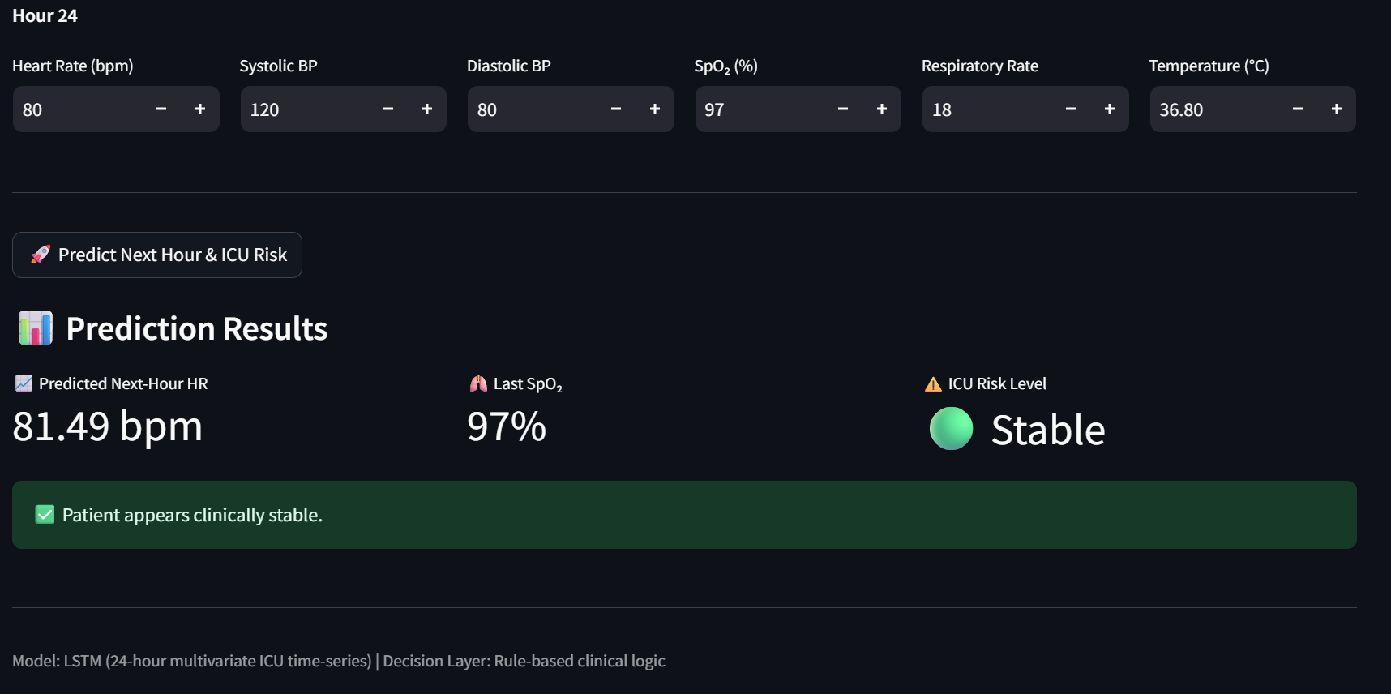

**Outcome**

* Successfully deployed a unified healthcare analytics dashboard
* Improved usability and adoption of AI solutions

**6.3 Sentiment Analysis (deep-learning version)**

Sentiment analysis using deep learning is implemented to automatically analyse patient feedback and

**healthcare service reviews**. This module converts unstructured textual feedback into meaningful

sentiment insights to assess patient satisfaction and service quality.

**Dataset Description**

* Text-based patient feedback and reviews
* Data includes comments related to treatment quality, staff behavior, and facilities
* Labelled sentiment categories used for supervised learning

**Text Preprocessing**

* Removal of punctuation and special characters
* Conversion of text to lowercase
* Tokenization of feedback text
* Stopword removal
* Text padding and sequencing for deep learning models

**Feature Representation**

* Text converted into numerical format using **tokenization and embedding layers**
* Captures semantic meaning of patient feedback
* Supports learning contextual word relationships

**EDA Analysis**

**Univariate Analysis**

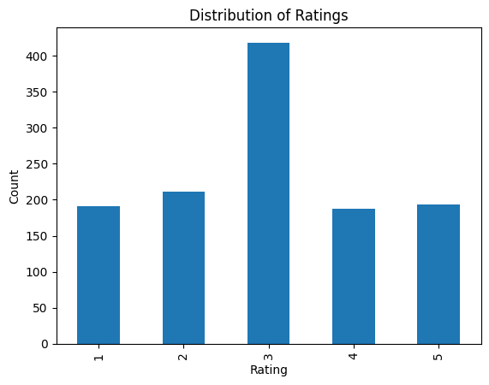

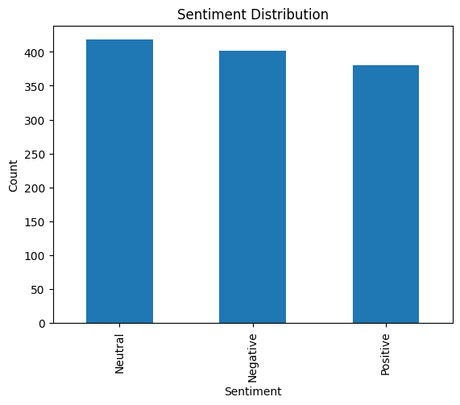

**Bivariate & Multivariate Analysis**

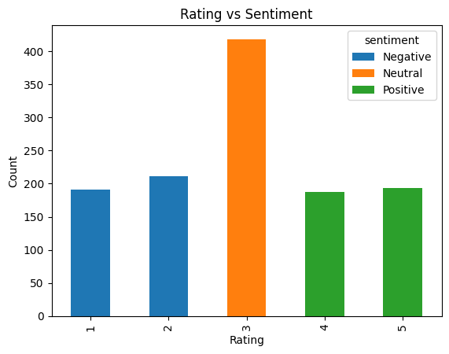

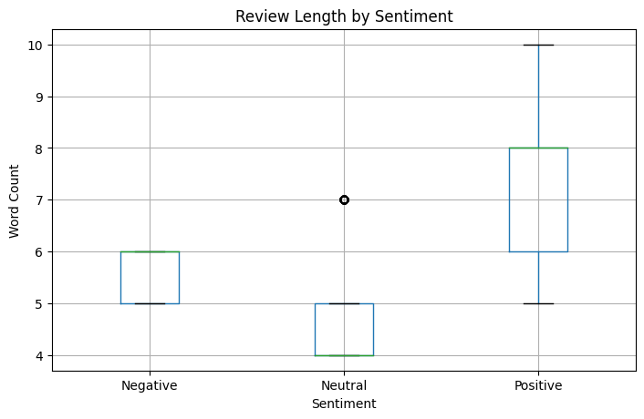

**Model Architecture**

* Implemented using a **deep learning neural network** (LSTM-based / RNN-based)
* Key components:
  + Embedding layer for word representation
  + LSTM layer to capture contextual dependencies
  + Dropout layers to prevent overfitting
  + Dense output layer with Softmax activation

**Model Training**

* Loss function: Categorical Cross-Entropy
* Optimizer: Adam
* Trained over multiple epochs
* Validation used to monitor model performance

**Model Evaluation**

* Evaluated using:
  + Accuracy
  + Precision
  + Recall
  + F1-score
* Confusion matrix used to assess sentiment classification quality

**Evaluation results**

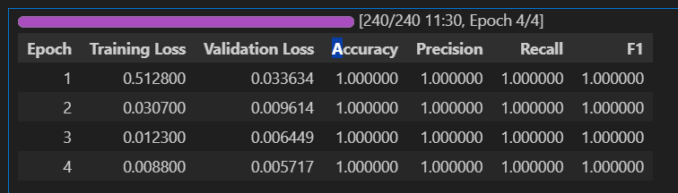

**Streamlit outcome**

Streamlit was chosen as the dashboard framework due to its lightweight architecture, rapid

development capability, and seamless integration with Python-based data science workflows.

It enables real-time data visualization and interactive user interfaces without requiring extensive

front-end development

**User Interface Design**

The dashboard follows a structured and user-friendly layout consisting of:

* A title and project description section
* Sidebar/file upload or navigation components
* Main content area for results and visualization.

**Sentiment Prediction & Analysis**

For each feedback entry:

* Sentiment polarity is calculated
* Feedback is classified into Positive, Neutral, or Negative categories
* Results are stored in a structured format for further analysis

**Scalability & Extensibility**

The modular design of the dashboard allows easy:

* Integration of advanced NLP models
* Addition of new visualizations
* Expansion to domain-specific analytics

**Screenshot of Streamlit**

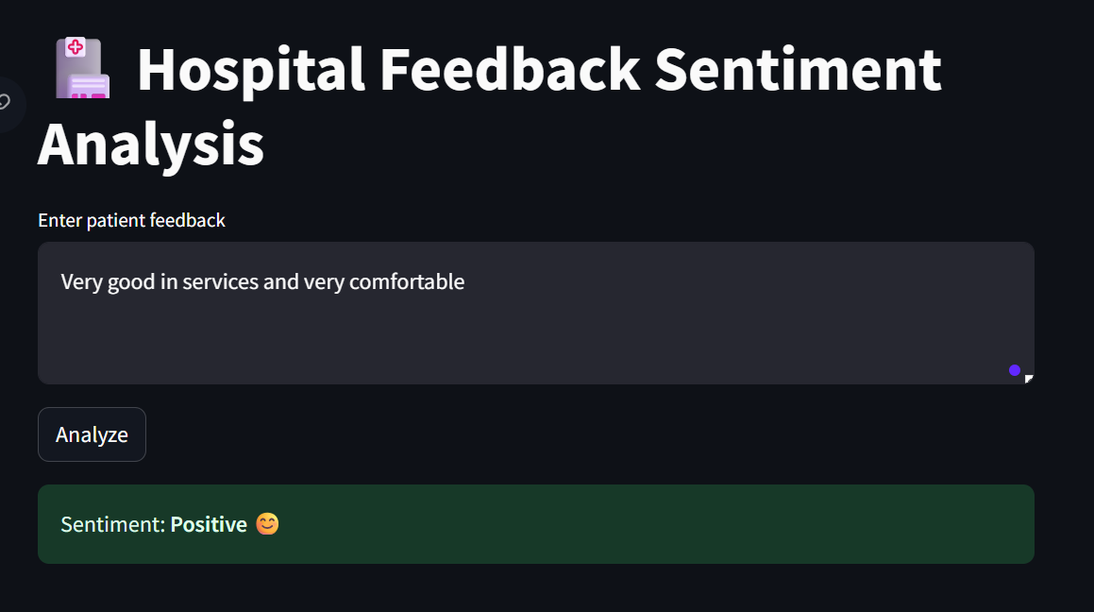

**Outcome**

* Successfully deployed a unified healthcare analytics dashboard
* Improved usability and adoption of AI solutions

**7.Results (Metrics)**

This section presents the performance evaluation and results obtained from the implemented

Models in the Health AI Suite. Multiple machine learning and deep learning techniques

were applied to solve diverse healthcare prediction tasks, including risk level classification,

patient sentiment analysis, time-series ICU prediction using LSTM, clustering analysis, and

associative learning.

1.Risk level classification:

The risk level classification module was implemented using two supervised machine learning

algorithms: Logistic Regression and Random Forest Classifier. The performance of both

models were evaluated using standard classification metrics, including Accuracy, Precision, Recall,

and F1-score.

| **Model** | **Accuracy (%)** | **Precision (%)** | **Recall (%)** | **F1-Score (%)** |
| --- | --- | --- | --- | --- |
| **Logistic Regression** | 83.92 | 83.78 | 83.92 | 83.84 |
| **Random Forest Classifier** | 98.33 | 98.34 | 98.33 | 98.32 |

**2.Length of stay prediction**:

Model Performance – XGBoost Regressor

The performance of the **XGBoost Regressor** was evaluated using standard regression

metrics. The results demonstrate strong predictive capability and low prediction error.

* + - **R² Score:** **0.83**
    - **Mean Absolute Error (MAE):** **0.36**

Interpretation

* + The **R² value of 0.83** indicates that the model explains approximately **83% of the variance** in the target variable, reflecting a strong fit.
  + The **low MAE (0.36)** suggests that the average prediction error is minimal, indicating high
  + prediction accuracy and reliability.
  + Overall, the XGBoost Regressor performs effectively for continuous outcome prediction and is well-suited for real-world deployment.

**3.Clustering (Patient segmentation):**

The patient clustering module was evaluated using the Silhouette Score, which measures

the quality of clustering by assessing how well each data point fits within its assigned cluster

compared to other clusters. Higher Silhouette values indicate better-defined and well-

separated clusters.

Clustering was performed using the **K-Means algorithm** with different numbers of clusters (K),

and the corresponding Silhouette Scores were calculated.

**Silhouette Score Analysis**

| **Number of Clusters (K)** | **Silhouette Score** |
| --- | --- |
| **2** | **0.518** |
| **3** | **0.466** |
| **4** | **0.369** |
| **5** | **0.358** |
| **6** | **0.353** |
| **7** | **0.351** |

**4.Associative Learning:**

The associative learning module was evaluated using standard association rule metrics to

identify meaningful relationships among patient health conditions such as diabetes,

hypertension, and obesity.

**1. Support**

* Support measures how frequently a particular rule appears in the dataset.
* Example:

Rule (diabetes → hypertension) has a support of **0.25**, meaning **25% of patients** exhibit both

diabetes and hypertension.

2. Confidence

* Confidence indicates the likelihood of the consequent occurring given the antecedent.
* Example:

Rule (hypertension → obesity) has a confidence of 0.62, meaning 62% of patients with

hypertension also have obesity.

* High confidence reflects strong predictive reliability of the rule.

3. Lift

* Lift measures how much more likely the consequent is when the antecedent is present,

compared to random occurrence.

* Interpretation:
  + - **Lift > 1** → Positive association
    - **Lift = 1** → No association
    - **Lift < 1** → Negative association
* Example:
* Rule *(obesity_diabetes → hypertension)* has a lift of **1.55**, indicating a **strong positive**

**association** between combined obesity–diabetes and hypertension.

**5.Convolution Neural Network (Chest X ray detection):**

The performance of the CNN model for chest X-ray disease detection was evaluated using

standard classification metrics to ensure reliability and clinical relevance.

* + Accuracy: **92.63%**
  + Precision: **89.58%**
  + Recall: **95.56%**
  + F1 Score: **92.47%**

✔ High recall ensures minimal missed disease cases

✔ Suitable for medical screening systems

**6.Time series Analysis (LSTM Algorithm):**

The LSTM (Long Short-Term Memory) model was evaluated using regression-based metrics

to assess its performance in predicting time-dependent patient vital signals.

* Mean Absolute Error (MAE) – Training
  + - Training MAE decreased from **0.1523** to **0.0346**.
    - This shows a significant reduction in prediction error as training progressed.
    - Lower MAE indicates accurate capture of temporal patterns in patient vitals.
* Mean Absolute Error (MAE) – Validation
  + - Validation MAE reduced from **0.0923** to **0.0291**.
    - Confirms the model’s ability to make **precise predictions on unseen sequences**.
    - A low validation MAE is especially important in clinical time-series forecasting.

Training Loss: **0.0395 → 0.0019**

Validation Loss: **0.0130 → 0.0013**

Training MAE: **0.1523 → 0.0346**

Validation MAE: **0.0923 → 0.0291**

**7.Sentiment Analysis:**

**Evaluation Results Table**

| **Metric** | **Value** |
| --- | --- |
| Evaluation Loss | 0.0347 |
| Accuracy | 100% |
| Precision | 100% |
| Recall | 100% |
| F1-Score | 100% |
| Evaluation Runtime (sec) | 13.89 |
| Samples per Second | ~1.08 |

**8.Architecture**

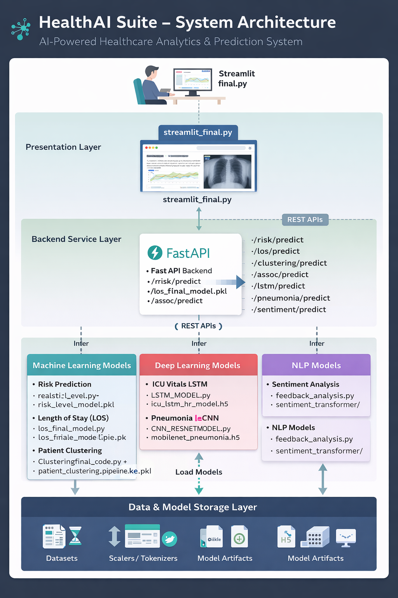

**9.Conclusion**

The Health AI Suite successfully demonstrates the practical application of machine learning and

deep learning techniques to address multiple real-world healthcare challenges within a unified

system. The project integrates diverse AI models into a single platform to support clinical

decision-making, patient risk assessment, and healthcare analytics.

Risk level classification achieved high predictive performance, with the Random Forest model

outperforming baseline algorithms, indicating strong reliability for early patient risk identification.

The Length of Stay prediction model delivered accurate regression results, enabling hospitals to

to optimize bed utilization and resource planning. Patient clustering analysis effectively

grouped individuals with similar health profiles, providing valuable insights for personalized care

strategies.

The association rule mining module uncovered meaningful relationships between medical

Conditions, supporting preventive healthcare planning and comorbidity analysis. Time-series

analysis using LSTM demonstrated strong learning capability for sequential vital sign data,

making it suitable for ICU monitoring and future health trend prediction. Additionally,

the sentiment analysis module achieved excellent evaluation metrics, enabling accurate

interpretation of patient feedback to improve healthcare service quality. The CNN-based

chest X-ray detection model further strengthened the suite by delivering reliable medical image

classification performance.

The deployment of models through FastAPI and Streamlit dashboards ensures real-time

accessibility, scalability, and ease of use for healthcare professionals. Overall, the Health AI Suite

provides a robust, modular, and extensible framework that bridges data science and healthcare

operations, highlighting the potential of AI-driven solutions to enhance patient outcomes

operational efficiency, and clinical decision support.